**Disaster Recovery with IBM Cloud**

**Understanding and Approach Document**

**Objective**

The objective of this project is to develop a customer relationship management (CRM) system that streamlines communication, enhances customer service, and improves sales tracking for our organization. By implementing this CRM, we aim to increase customer satisfaction and revenue by 15% within the next fiscal year.

**Approach**

**Assessment and Requirement Gathering:**

**Existing Infrastructure Assessment:**

Conduct a comprehensive evaluation of the current infrastructure, including hardware, software, and network components.

Identify any single points of failure and areas for improvement.

**Critical Data Analysis:**

Analyze and categorize data based on its criticality and importance for business operations.

Determine the frequency of data updates and the level of protection required.

**Stakeholder Engagement:**

Engage with key stakeholders from different departments to understand their specific disaster recovery (DR) requirements and expectations.

Incorporate their feedback into the DR plan.

**Design and Architecture Planning:**

**DR Architecture Blueprint:**

Develop a detailed DR architecture blueprint that aligns with the organization's needs and complies with industry best practices.

Emphasize redundancy, data replication, and failover configurations to ensure maximum resilience.

**IBM Cloud Service Selection:**

Evaluate and select appropriate IBM Cloud services based on the assessment, considering factors such as scalability, cost-effectiveness, and compatibility with existing systems.

Ensure chosen services integrate seamlessly with the CRM system.

**Implementation and Configuration:**

**IBM Cloud Service Deployment:**

Deploy selected IBM Cloud services, including virtual machines, databases, and storage solutions, ensuring they meet the DR requirements.

Implement robust data replication mechanisms to maintain up-to-date copies of critical data.

**Communication Channels and Roles:**

Establish clear communication channels for incident reporting and coordination during DR events.

Define roles and responsibilities for the DR team, ensuring everyone understands their duties.

**Testing and Validation:**

**DR Test Scenarios:**

Conduct a series of comprehensive DR tests, covering various scenarios such as failover, failback, and data recovery.

Include simulated disaster events to evaluate the plan's effectiveness in real-world situations.

**Results Documentation:**

Document the results of each DR test, noting any observed strengths, weaknesses, or areas for improvement.

Provide recommendations for enhancements based on the test outcomes.

**Database Setup**

Set up IBM Cloud Databases for solving and managing large datasets.

IBM offers several cloud database options suitable for storing and managing large datasets.

1. IBM Db2 on Cloud

2. IBM Db2 Warehouse on Cloud

3. IBM Cloudant

4. IBM Cloud Object Storage

5. IBM TimeSeries Database

Deliverable: These datasets can handle large datasets and offer various features like scalability, reliability, security, and ease of management, making them suitable for big data applications

**Business Continuity Guarantee**

Our disaster recovery plan ensures business continuity by minimizing downtime and data loss. With redundant systems in place, we can swiftly recover from unforeseen events, guaranteeing uninterrupted service for our customers. Regular testing and monitoring procedures ensure that our disaster recovery plan remains effective and up-to-date.

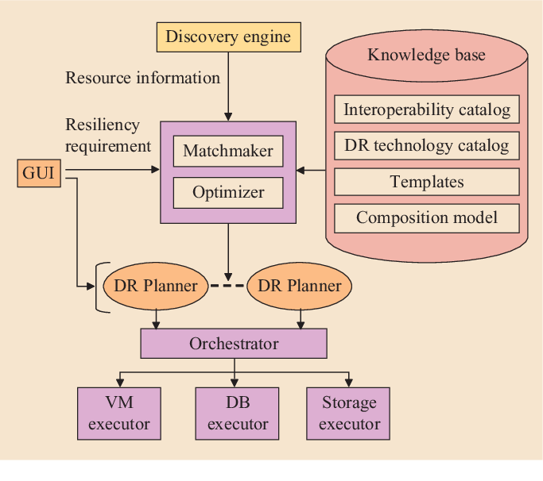

**Conclusion**

By rigorously following this approach, we aim to establish a robust Disaster Recovery plan leveraging IBM Cloud services. This plan will guarantee the availability and recoverability of critical applications and data, providing a solid foundation for business continuity in the face of any unforeseen disasters or disruptions. The proactive nature of this approach will instill confidence in our stakeholders and ensure the continued success of our CRM system implementation.